Equation is:
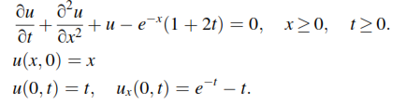
Fourier transform of equation is:
