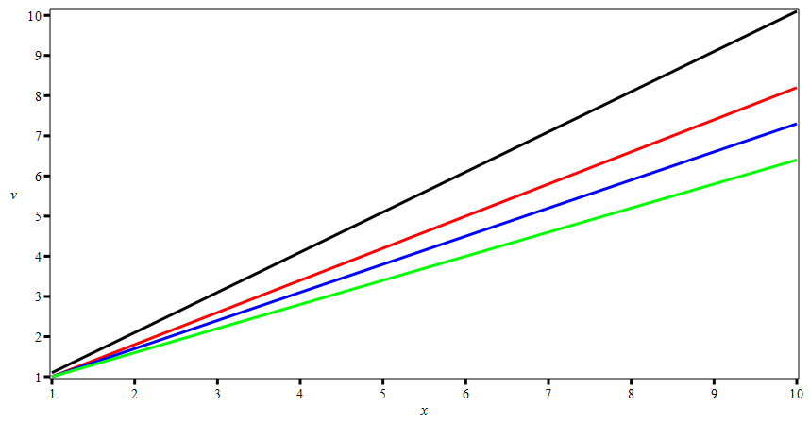
Above is exported from Maple as a GIF
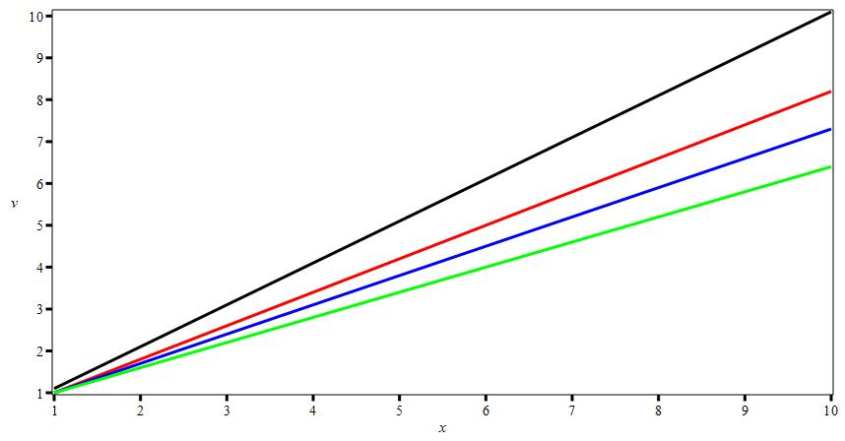
Above is exported from Maple as a JPEG
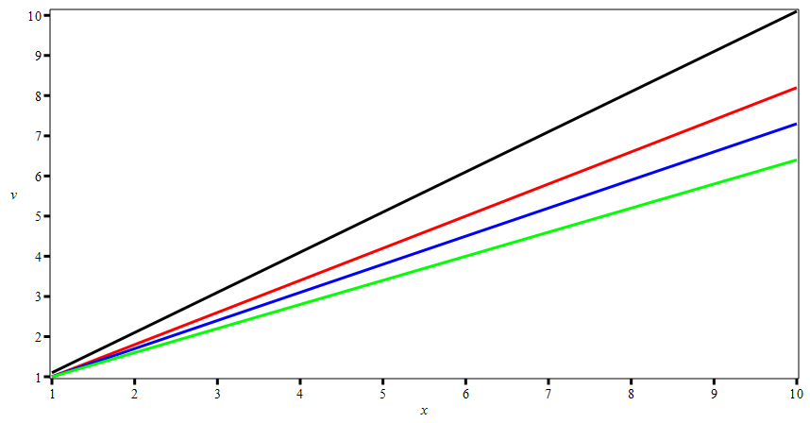
Above is exported from Maple as PNG

