Exposed for drag force: where v=abs(**V**) , d=0.2mm . Co, mu and rho are given.

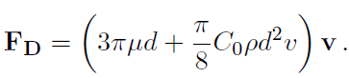

Total drag force can be written as: F_d=abs(**FD**) ..

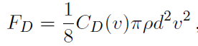

Cd(v) is drag coeffient. Find expression for Cd(v) and write it like **Cd= V ->…** and returns Cd(v)

Use all parameters as global variables.